

LETTER GENERATOR

GLASTON VELVARTS

BOARD ROLLNO:



**Certificate**

This is to certify that Glaston Velvarts has worked on LETTER GENERATOR under my supervision and has completed it to my satisfaction.

**R. NAGPAL**

Index

1)Aim

2)data stored/name of files

3)modules and functions used

4)code of project

5)output screen

6)Acknowledgement

7)Bibliography

**AIM**

To generate formal and informal letters based on the data provided by the user as a text file.



*Data stored/ Name of file:*

**Leave.txt**

**Principalstream.txt**

**Principalbackup.txt**

**Bossleave.txt**

**Promotion.txt**

**Resignation.txt**

**Informal.txt**

**Modules and functions used:**

Modules used: -

1)datetime

Functions used: -

1. class color
2. **String Alignment (centre)**
3. **Python format function(format)**
4. String function(upper)
5. String function(replace)

**Code of project**

**from datetime import date**

**class color:**

**PURPLE = '\033[95m'**

**CYAN = '\033[96m'**

**DARKCYAN = '\033[36m'**

**BLUE = '\033[94m'**

**GREEN = '\033[92m'**

**YELLOW = '\033[93m'**

**RED = '\033[91m'**

**BOLD = '\033[1m'**

**UNDERLINE = '\033[4m'**

**END = '\033[0m'**

**ch='yes'**

**cstr=color.UNDERLINE + 'WELCOME TO LETTER GENERATOR' + color.DARKCYAN + color.BOLD + color.END**

**print(cstr.center(90),'\n')**

**while ch!='no':**

**ch=input('press any key to continue or no to quit-')**

**if ch=='no':**

**i=color.DARKCYAN +'X_X_X_X_X_X_X_THANK YOU FOR USING OUR APPLICATION_X_X_X_X_X_X' + color.END**

**print(i.center(100),'\n')**

**break**

**print('\nwhich letter do you want to write:')**

**print('1.formal letter\n2.informal letter')#please note when you select informal letter you have to make your own letter**

**ch1=input('\nenter choice 1 or 2-')**

**if ch1=='1':**

**print('you have selected formal letter')**

**print('select which one would you like to access:\n1.to your principal\n2.to your boss')**

**a='yes'**

**while a!='3':**

**a=input('enter option 1 to access letter to principal, option 2 to letter to boss and 3 to go back to previous step-')**

**if a=='1':**

**ch='yes'**

**while ch!='4':**

**ch=input('please enter one of the following option:\n1.leave\n2.backup class\n3.stream change\n:')**

**if ch=='1':**

**print('you have entered the topic of leave-')**

**file=open('user1','w+')**

**file1=open('principalleave.txt','r+')**

**h='letter to the principal'**

**h=h.upper()**

**h=color.UNDERLINE + h + color.BOLD + color.END**

**h=h.center(100)**

**sub=input('enter subject')**

**sub=sub.upper()**

**sub='subject: {}'.format(sub)**

**n=input('enter your name-')**

**add1=input('enter sender address line 1-')**

**add2=input('enter sender address line 2-')**

**add3=input('enter sender address line 3-')**

**rec1='THE PRINCIPAL'**

**rec2=input('enter receiver address line 2-')**

**rec3=input('enter receiver address line 3-')**

**today=date.today()**

**d1=today.strftime('%B%d,%Y')**

**N=n.upper()**

**cl=input('enter your class-')**

**sec=input('enter your section-')**

**nlt=input('enter number of leaves you want to take-')**

**rea=input('enter reason-')**

**sub=color.UNDERLINE + sub + color.END**

**a=color.DARKCYAN + n + color.END**

**s=add1+'\n'+add2+'\n'+add3+'\n\n'**

**r=rec1+'\n'+rec2+'\n'+rec3+'\n'**

**k=file1.read()**

**k=k.replace('<name>',n)**

**k=k.replace('<class>',cl)**

**k=k.replace('<section>',sec)**

**k=k.replace('<no. of leaves taken>',nlt)**

**k=k.replace('<reason>',rea)**

**file.write('\n'+h+'\n\n'+s+d1+'\n\n'+r+'\n\n'+sub+'\n'+k+'\n'+a+'\n'+N+'\n\n')**

**file.seek(0)**

**s=file.read()**

**print(s)**

**file.close()**

**file1.close()**

**elif ch=='2':**

**print('you have entered the topic of back up class')**

**file=open('user2.txt','w+')**

**file1=open('principalbackup.txt','r+')**

**sub=input('enter subject:')**

**sub=sub.upper()**

**sub='subject: {}'.format(sub)**

**n=input('enter your name:')**

**add1=input('enter sender address line 1-')**

**add2=input('enter sender address line 2-')**

**add3=input('enter sender address line 3-')**

**rec1='THE PRINCIPAL'**

**rec2=input('enter receiver address line 2-')**

**rec3=input('enter receiver address line 3-')**

**today=date.today()**

**d1=today.strftime('%B%d,%Y')**

**N=n.upper()**

**h='letter to the principal'**

**h=h.upper()**

**h=color.UNDERLINE + h + color.BOLD + color.END**

**h=h.center(100)**

**subject=input('enter the subject for which you need back up-')**

**cl=input('enter your class-')**

**sec=input('enter your section-')**

**date1=input('enter the start of your absence in the form of dd-mm-yyyy-')**

**date2=input('enter till when you were absent in the form of dd-mm-yyyy-')**

**rea=input('enter the reason-')**

**sub=color.UNDERLINE + sub + color.END**

**a=color.DARKCYAN + n + color.END**

**s=add1+'\n'+add2+'\n'+add3+'\n\n'**

**r=rec1+'\n'+rec2+'\n'+rec3+'\n'**

**k=file1.read()**

**k=k.replace('<name>',n)**

**k=k.replace('<class>',cl)**

**k=k.replace('<section>',sec)**

**k=k.replace('<subject>',subject)**

**k=k.replace('<reason>',rea)**

**k=k.replace('<date1>',date1)**

**k=k.replace('<date2>',date2)**

**file.write('\n'+h+'\n\n'+s+d1+'\n\n'+r+'\n\n'+sub+'\n'+k+'\n'+a+'\n'+N+'\n\n')**

**file.seek(0)**

**s=file.read()**

**print(s)**

**file.close()**

**file1.close()**

**elif ch=='3':**

**print('you have choosen the topic of changing the stream-')**

**file=open('user3.txt','w+')**

**file1=open('principalstream.txt','r+')**

**sub=input('enter subject of the letter-')**

**sub=sub.upper()**

**sub='subject: {}'.format(sub)**

**h='letter to the principal'**

**h=h.upper()**

**h=color.UNDERLINE + h + color.BOLD + color.END**

**h=h.center(100)**

**n=input('enter name to be inserted-')**

**cl=input('enter your class-')**

**sec=input('enter your section-')**

**add1=input('enter address line 1-')**

**add2=input('enter address line 2-')**

**add3=input('enter address line 3-')**

**rec1='THE PRINCIPAL'**

**rec2=input('enter receiver address line 2-')**

**rec3=input('enter receiver address line 3-')**

**today=date.today()**

**d1=today.strftime('%B%d,%Y')**

**N=n.upper()**

**stream1=input("enter the stream you have-")**

**stream2=input("enter the stream you want-")**

**sub=color.UNDERLINE + sub + color.END**

**a=color.DARKCYAN + n + color.END**

**s=add1+'\n'+add2+'\n'+add3+'\n\n'**

**r=rec1+'\n'+rec2+'\n'+rec3+'\n'**

**k=file1.read()**

**k=k.replace('<name>',n)**

**k=k.replace('<class>',cl)**

**k=k.replace('<section>',sec)**

**k=k.replace('<stream1>',stream1)**

**k=k.replace('<stream2',stream2)**

**file.write('\n'+h+'\n\n'+s+d1+'\n\n'+r+'\n\n'+sub+'\n'+k+'\n'+a+'\n'+N+'\n\n')**

**file.seek(0)**

**s=file.read()**

**print(s)**

**file.close()**

**file1.close()**

**elif a=='2':**

**print('you have selected letter to the boss')**

**ch='yes'**

**while ch!='4':**

**print('choose one of the following options to proceed:\n1.leave\n2.promotion\n3.resignation')**

**ch=input('\nenter one of the following-\n')**

**if ch=='1':**

**print('you have selected letter of leave to the boss')**

**file=open('user4.txt','w+')**

**file1=open('bossleave.txt','r+')**

**n=input('enter your name as an employee-')**

**h='letter to the boss'**

**h=h.upper()**

**h=color.UNDERLINE + h + color.BOLD + color.END**

**h=h.center(100)**

**sub=input('enter subject of the letter-')**

**sub=sub.upper()**

**sub='subject:{}'.format(sub)**

**ad1=input('enter senders address line 1-')**

**ad2=input('enter senders address line 2-')**

**ad3=input('enter senders address line 3-')**

**today=date.today()**

**d1=today.strftime('%B%d,%Y')**

**N=n.upper()**

**rec1='TO'**

**rec2=input('name of boss-')**

**rec3=input('enter designation of the boss-')**

**nc=input('enter name of the company/institute-')**

**nlt=input('enter no. of leaves you want to take-')**

**date1=input('enter the date from when you will be on a leave in the form of dd-mm-yyyy-')**

**rea=input('enter reason-')**

**date2=input('enter the date till which you are planning to take the leave in the form of dd-mm-yyyy-')**

**sub=color.UNDERLINE + sub + color.END**

**a=color.DARKCYAN + n + color.END**

**s=ad1+'\n'+ad2+'\n'+ad3**

**r=rec1+'\n\n'+rec2+'\n'+rec3+'\n'+nc**

**k=file1.read()**

**k=k.replace('<no. of leaves taken>',nlt)**

**k=k.replace('<reason>',rea)**

**k=k.replace('<date1>',date1)**

**k=k.replace('<date2>',date2)**

**file.write('\n'+h+'\n\n'+s+’\n’+d1+'\n\n'+r+'\n\n'+sub+'\n'+k+'\n'+a+'\n'+N+'\n\n')**

**file.seek(0)**

**s=file.read()**

**print(s)**

**file.close()**

**file1.close()**

**elif ch=='2':**

**print('you have selected letter for promotion to the boss.')**

**file=open('user5.txt','w+')**

**file1=open('promotion.txt','r+')**

**n=input('enter the name of the employee')**

**sub=input('enter subject of the letter ')**

**h='letter to the boss'**

**h=h.upper()**

**h=color.UNDERLINE + h + color.BOLD + color.END**

**h=h.center(100)**

**sub=sub.upper()**

**sub='subject:{}'.format(sub)**

**ad1=input('enter sender address line 1-')**

**ad2=input('enter sender address line 2-')**

**ad3=input('enter sender address line 3-')**

**today=date.today()**

**d1=today.strftime('%B%d,%Y')**

**N=n.upper()**

**rec1='TO'**

**rec2=input('enter name of boss-')**

**rec3=input('enter designation of boss-')**

**nc=input('enter the name of company/institution-')**

**today=date.today()**

**d1=today.strftime('%B%d,%Y')**

**N=n.upper()**

**job1=input('Please enter the post that you desire-')**

**job2=input('Please enter the post you currently have-')**

**sub=color.UNDERLINE + sub + color.END**

**a=color.DARKCYAN + n + color.END**

**s=ad1+'\n'+ad2+'\n'+ad3+'\n\n'**

**r=rec1+'\n'+rec2+'\n'+rec3+'\n'+nc**

**k=file1.read()**

**k=k.replace('<name>',n)**

**k=k.replace('<desired job title>',job1)**

**k=k.replace('<your current job title>',job2)**

**file.write('\n'+h+'\n\n'+s+d1+'\n\n'+r+'\n\n'+sub+'\n\n'+k+'\n'+a+'\n'+N+'\n\n')**

**file.seek(0)**

**s=file.read()**

**print(s)**

**file.close()**

**file1.close()**

**elif ch=='3':**

**print('you have selected letter for resignation to the boss-')**

**file=open('user6.txt','w+')**

**file1=open('resignation.txt','r+')**

**n=input('enter the name of the employee-')**

**sub=input('enter subject of the letter-')**

**sub=sub.upper()**

**sub='subject:{}'.format(sub)**

**h='letter to the boss'**

**h=h.upper()**

**h=color.UNDERLINE + h + color.BOLD + color.END**

**h=h.center(100)**

**ad1=input('enter sender address line 1-')**

**ad2=input('enter sender address line 2-')**

**ad3=input('enter sender address line 3-')**

**N=n.upper()**

**rec1='TO'**

**rec2=input('enter name of boss-')**

**rec3=input('enter designation of boss-')**

**nc=input('enter name of company/institute-')**

**today=date.today()**

**d1=today.strftime('%B%d,%Y')**

**posname=input("enter your position name-")**

**sub=color.UNDERLINE + sub + color.END**

**a=color.DARKCYAN + n + color.END**

**s=ad1+'\n'+ad2+'\n'+ad3+'\n\n'**

**r=rec1+'\n\n'+rec2+'\n'+rec3+'\n'+nc**

**k=file1.read()**

**k=k.replace('(name)',n)**

**k=k.replace('(company name)',nc)**

**k=k.replace('(position name)',posname)**

**file.write('\n'+h+'\n\n'+s+d1+'\n\n'+r+'\n\n'+sub+'\n\n'+k+'\n'+a+'\n'+N+'\n\n')**

**file.seek(0)**

**s=file.read()**

**print(s)**

**file.close()**

**file1.close()**

**elif ch1=='2':**

**print('you have selected informal letter')**

**print('\n')**

**ch='yes'**

**while ch!='no':**

**ch=input('press any key to continue or no to stop-')**

**file=open('custom.txt','w+')**

**file1=open('informal.txt','r')**

**if ch=='no':**

**i=color.DARKCYAN +'X_X_X_X_X_X_X_THANK YOU FOR USING OUR APPLICATION_X_X_X_X_X_X' + color.END**

**print(i.center(100),'\n')**

**break**

**ad1=input('enter your address line 1-')**

**ad2=input('enter your address line 2-')**

**ad3=input('enter your address line 3-')**

**name1=input("enter the name of relative to whom you are writing this letter")**

**para1=input("enter the first paragraph of the letter-")**

**para2=input("enter the second paragraph of the letter-")**

**para3=input("enter the third paragraph of the letter-")**

**n=input("enter your name-")**

**h='informal letter'**

**h=h.upper()**

**h=color.UNDERLINE + h + color.BOLD + color.END**

**h=h.center(100)**

**a=color.DARKCYAN + n + color.END**

**today=date.today()**

**d1=today.strftime('%B%d,%Y')**

**N=n.upper()**

**s=ad1+'\n'+ad2+'\n'+ad3+'\n\n'**

**k=file1.read()**

**k=k.replace('<name1>',name1)**

**k=k.replace('<para1>',para1)**

**k=k.replace('<para2>',para2)**

**k=k.replace('<para3>',para3)**

**s=ad1+'\n'+ad2+'\n'+ad3+'\n\n'**

**file.write('\n'+h+'\n\n'+s+ d1 +'\n\n'+ k +'\n'+a+'\n'+N+'\n\n')**

**file.seek(0)**

**s=file.read()**

**print(s)**

**file.close()**

**file1.close()**

**Output screen**

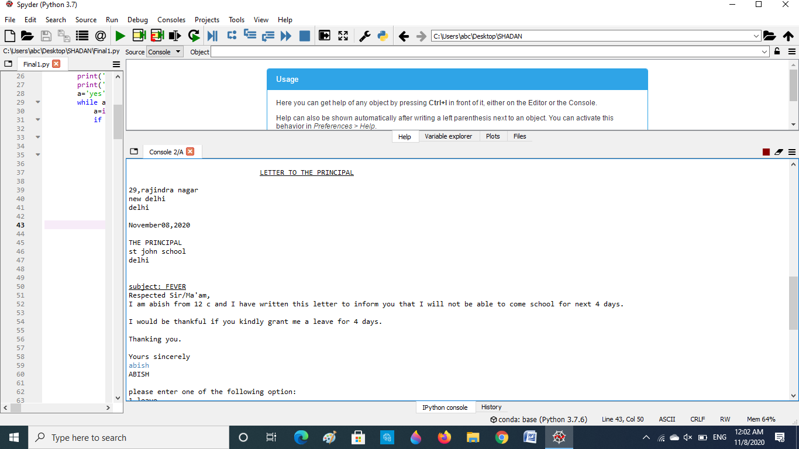

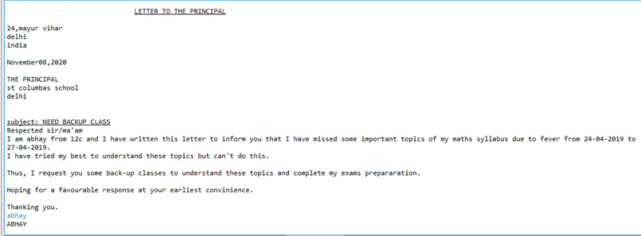

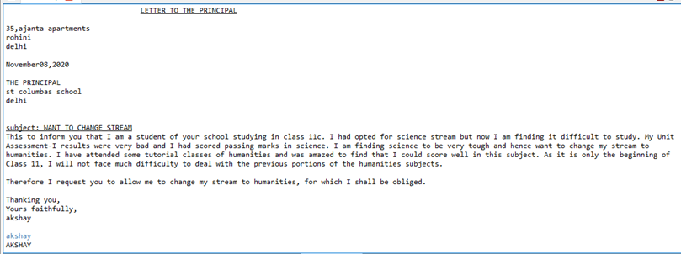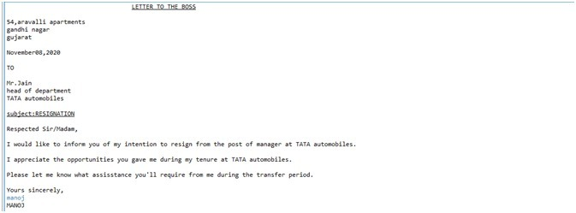

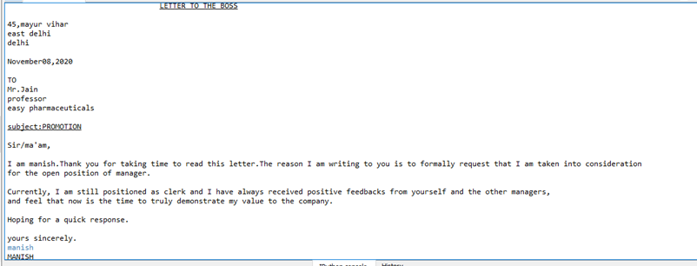

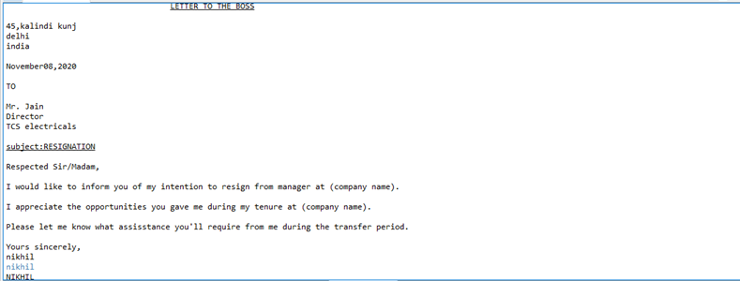

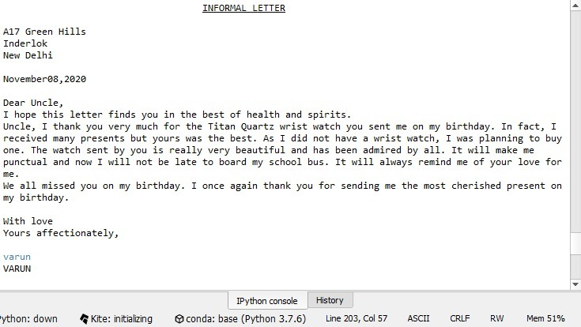

Acknowledgement

I would like to express my gratitude towards my teacher Mrs. R. Nagpal for their constant support and encouragement which helped me in completing this project. My thanks and appreciations also go to my colleague in developing the project and people who have willingly helped me out with their abilities.

Bibliography

<https://www.techbeamers.com/python-datetime/>

<https://www.a1letters.com/index.php>